From "Independant WHO", 18h00GMT on 22/3/2011
The IAEA website states:
High levels of beta-gamma contamination have been measured between 16-58 km from the plant. Available results show contamination ranging from 0.2-0.9 MBq per square metre.
The comparable maps from Chernobyl are shown below for Cs-137

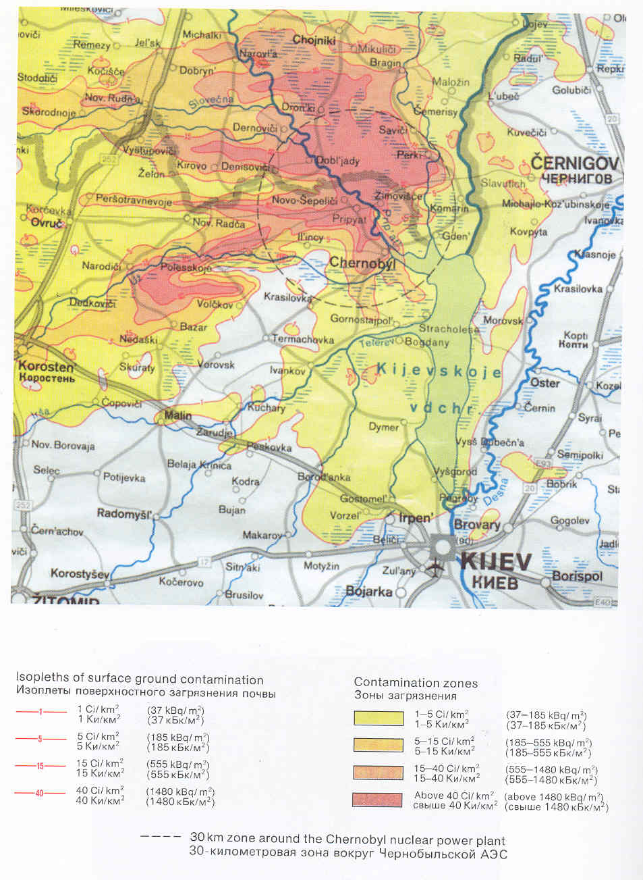

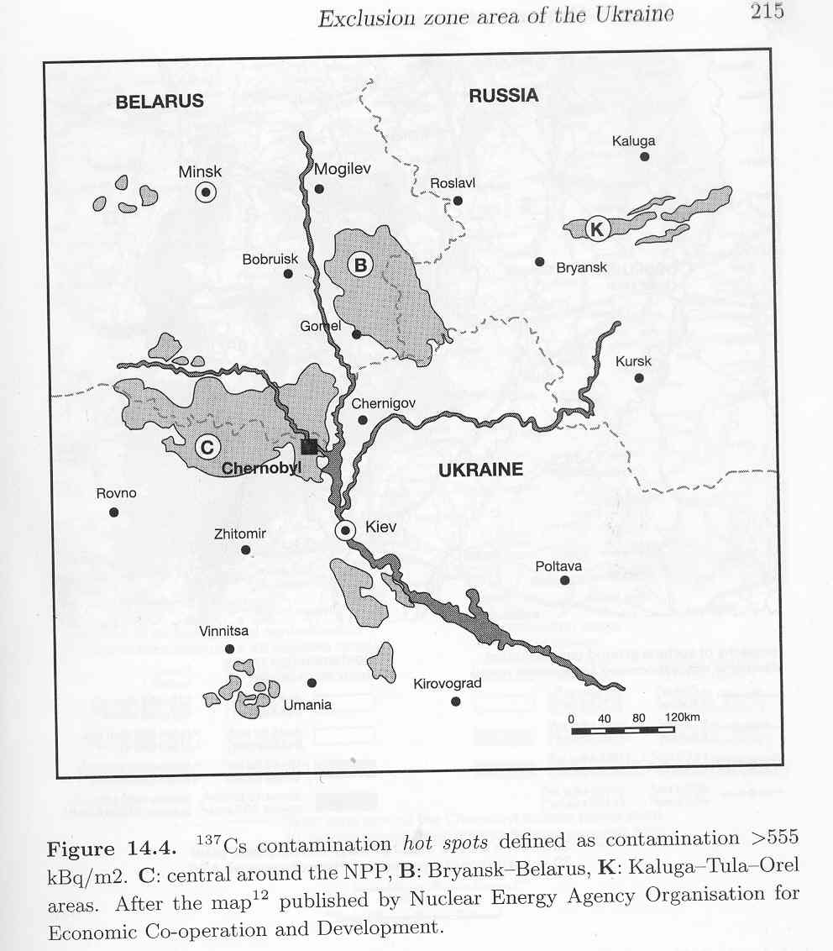

In the above map, the “hot spots” are defined as greater than 0.55MBq/sq:m. This the IAEA are saying that up to 60km from Fukushima the activity is more than twice the level defined as a hotspot in the maps shown. These maps are from the European Commission (the lower) and the Soviet authorities (upper).

This means the following:.

- The explosions vaporised some or all of the spent fuel tanks on reactors number 1-3.
- The accident is as serious as Chernobyl, which is what I stated on Friday last and in various TV and radio interviews
- There is every likelihood that the pressure vessel of at least one reactor is open
- There is serious contamination of the sea which will extend the radioactivity to coastal dwellers for hundreds of kilometres through inhalation of sea-to-land transfer of radionuclides and seafood
- The health effects will be serious and we must consider that contamination will probably be global, though the levels may not be apparent for a while
- Public within 150km should leave the area immediately.

