THE TECHNICAL UNIVERSITY OF DENMARK
DEPARTMENT OF ELECTROPHYSICS
DK-2800 Lyngby, Denmark

NUCLEAR SHIP ACCIDENTS
DESCRIPTION AND ANALYSIS
by
P.L.OLGAARD
MAY 1993

Abstract
In this report available information on 28 nuclear ship accident and incidents is considered. Of these 5 deals with U.S. ships and 23 with USSR ships. The ships are in almost all cases nuclear submarines. Only events that involve the nuclear propulsion plants, radiation exposures, fires / explosions and sea water leaks into the submarines are considered. Comments are made on each of the events, and at the end of the report an attempt is made to point out the weaknesses of the submarine designs which have resulted in the accidents.
It is emphasized that much of the available information is of a rather dubious nature. Consequently some of the assessments made may not be correct.

LIST OF CONTENTS
Page
1 . INTRODUCTION
2. SOURCES OF INFORMATION
3. TYPES OF ACCIDENTS/ INCIDENTS
4. NUCLEAR SHIP ACCIDENTS
July l961. Soviet Ballistic Missile Submarine Accident
1962. US SSN Skate Incident
April 1963. US SSN Thresher Accident
Around 1966. Soviet Nuclear Submarine Accident
Around 1966. Icebreaker NS Lenin Accident?
1966-68. Soviet Leninskyj Komsomol Submarine Accident
Dec. 1967. US Nuclear Submarine Accident
1967. Soviet November Class Submarine Incident
1968. Soviet Nuclear Submarine Accident?
May 1968. US SSN Scorpion Accident
Apr. 1970. Soviet November Class Submarine Accident
Apr.-May 1970. Soviet Nuclear Submarine Accident?
Feb. 1972. Soviet Hotel-II Class Submarine Accident
Dec. 1972 - Jan. 1973. Soviet Nuclear Submarine Accident
Apr. 1973. US SSN Guardfish Incident
Oct. 1976. Soviet Nuclear Submarine Accident
1977. Soviet Nuclear Submarine Accident
1977. Soviet Nuclear Submarine Radiation Accident
Aug. 1978. Soviet Echo-II Class Submarine Incident
Aug. 1980. Soviet Echo Class Submarine Accident
Sep. 1980. Soviet Nuclear Submarine Accident
June 1983. Soviet Charlie Class Submarine Accident
Jan. 1986. Soviet Echo-II Class Submarine Incident
Oct. 1986. Soviet Yankee-I Class Submarine Accident
Apr. 1989. Soviet Komsomolets Submarine Accident
June 1989. Soviet Echo-II Class Submarine Accident
July 1989. Soviet Alfa Class Submarine Incident
Jan. 1990. Soviet Admiral Ushakov Class Cruiser Incident
5. POTENTIAL RISKS OF NUCLEAR NAVAL ACCIDENTS
6. ANALYSIS OF THE ACCIDENTS/INCIDENTS
7. CONCLUDING REMARKS
8. REFERENCES
1. INTRODUCTION
In Denmark a "Nuclear Preparedness Group" has been established in cooperation between the Riso National Laboratory, the Technical University of Denmark and the Danish Nuclear Inspectorate.
This group collects information about nuclear facilities in the areas surrounding Danish territory and follows the nuclear development in general. The reasoning behind the group is to ensure that the necessary information is available, should the Danish authorities need information about nuclear facilities or events.
A major activity of the group has been to collect information about nuclear power plants situated not too far from Danish territory. In addition an attempt has also been made to collect information on nuclear ships. At several occasions nuclear ships have sailed through the Danish straits. It should also be remembered that the Faroe Islands and Greenland are part of the Danish Kingdom. Thus all traffic with nuclear ships in the North Atlantic may be of relevance to Danish authorities. Accidents with this type of ship may give rise to radioactive pollution which may again affect the fishing fleet.
The information on nuclear ships which the group has attempted to collect includes information on accidents with nuclear ships, safety aspects of nuclear ship propulsion plants ships and sea disposal of nuclear reactors. The reason for collecting this information is to create a better basis for risk assessments in case of nuclear ship accidents or in case of release of radioactivity near the sea bottom from disposed reactors or from sunken nuclear ships.
While it has not been too difficult to obtain information about civilian nuclear ships (cfr. ref. 1), reliable information on nuclear naval ships is for reasons discussed in section 2 of this report not readily available.

2. SOURCES OF INFORMATION
There exists quite a number of books (cfr. e.g. ref. 2, 3, and 4) and articles in addition to naval handbooks which contain information on naval nuclear ships. However, much of this information is unreliable since it is based on guesstimates rather than on facts. This is hardly surprising since naval authorities do not - for obvious reasons - wish to reveal design information on the strengths / weaknesses of their nuclear ships to potential adversaries.
The secrecy applies not only to the design and the safety features of the nuclear naval ships, but also to information on nuclear ship accidents. Here the official authorities have sometimes a tendency to down-play the seriousness of an accident while at the same time anti-nuclear and anti-military organizations will exaggerate the seriousness. Expressed in a simplified way the anti-nuclear groups will make an incident an accident and accidence a catastrophe, while the official authorities will have a tendency to do it the other way round.
Finally the anti-nuclear and other groups often try to imply that they have access to classified information by making categoric statements on topics where it is obvious that they do not have the necessary knowledge, e.g. on the design of nuclear naval ships, on the seriousness of accidents, and on the risks of pollution.
These factors combined with the often meager information available, makes it difficult for the objective observer to get a correct picture of the accidents.
This is in particular true for nuclear accidents within the USSR Navy. Here, due to the closed nature of the Soviet society, the information on accidents available in the west was usually second or third hand information, often passed on by people who were neither unbiased nor technically competent. Thus it is impossible to know whether the information was completely true or without any foundation or somewhere in between. Fortunately this situation is now changing.

3. TYPES OF ACCIDENTS/INCIDENTS
It is unavoidable that nuclear ships become involved in incidents and accidents in the same way as ordinary ships. This is in particular so since almost all nuclear ships are naval vessels. Such vessels are designed for use - and the crews are trained - under circumstances where ordinary safety measures cannot always be taken. However, in order to compensate for this, nuclear naval ships are likely to be designed with such safety features that even if accidents occur, the consequences should be
limited.
The most common cases of nuclear ship incidents/accidents are collisions, problems with the nuclear power plant, groundings, fires and explosions and development of leaks in the hull of submarines. It is of interest to note that collisions and groundings seldom leads to serious accidents. The reason is undoubtedly that naval ships are designed to function even under very difficult circumstances, i.e. under enemy attack with exploding bombs, granates and depth charges. To survive under these circumstances the ship designs have to be very robust, and such designs also make the ships resistant to collision and
grounding damage.
In this report an attempt has been made to make, as objectively as possible, an assessment of available information on nuclear ship accidents which (a) involved the nuclear propulsion plant, directly or indirectly, (b) radiation accidents, (c) fires/explosions, and (d) leaks in the hull. Accidents in harbors or at shipyards are not included since here the reactor(s) has not recently been in operation.
It should be emphasized that due to the questionability of much of the information on which this report is based, it is very likely to contain errors.

4. NUCLEAR SHIP ACCIDENTS/INCIDENT
There exists no agreed definition of nuclear ship accidents. In this report it will be defined as all events that are claimed to have involved the sinking of nuclear ships, fires, damage to, including melt-down of, the reactor fuel, and/or serious radiation exposure of crew members.

July 1961. Soviet Ballistic Missile Submarine Accident
According to raw western intelligence reports a soviet Hotel class submarine, carrying ballistic missiles, suffered a serious leakage in a coolant pipe of the nuclear power plant when the submarine was near the coast of England. The boat was returning from a training exercise. The leakage caused serious contamination of parts of the ship and radiation exposure of crew members. The radiation level was reported to be 5 R/hr in the area where the pipe broke. The submarine managed to reach its home base where it had to be ventilated for 2 month.
This report was in 1990 confirmed and supplemented with information in the Russian press and at scientific meetings. According to the Russian sources the first Soviet ballistic nuclear submarine (western designation: Hotel class) was on July 4th, 1961, sailing submerged in the North-Western Atlantic, several thousand kilometers from its home base. At 4 o'clock in the morning a leak developed in the primary system in one of the two reactors of the submarine. The leak was due to a crack in a pipe which was part of the reactor control system (possibly the pressurizer system?). During operation the temperature of the cooling water is around 300°C. The reactor pressure, maintained by use of a high pressure gas system, is several hundred atmospheres (?).
The leak caused a rapid decrease in the reactor pressure which approached atmospheric pressure. The reactor water started to boil, and the cooling of the core became insufficient. The control system worked correctly and shut down the reactor automatically.
At this point a fire was ignited (the reasons for the fire were not given) in the reactor room of the disabled reactor, but it was extinguished. The submarine surfaced, for the first time after several weeks of submersion.
Radioactivity started to spread in the submarine due to the leak and to the fire. The dose rate in the control room of the submarine was (up to?) 50 R/hr, and it was very high in some areas of the reactor room. All compartments of the submarine were hermetically sealed, but it was impossible to stop all traffic between the compartments due to the development of the events.
The major problem was the cooling of the core. Before the accident the reactor had been operating at full power, and without continued cooling of the core the fuel elements would overheat due to the decay heat. The emergency core cooling system did not function, and the temperature of the fuel increased continuously and reached 800°C. Hence there was a risk of core melt-down. This could result in a very serious situation.
In order to avoid this situation an emergency core cooling system had to be manufactured and installed within a few hours with the means available on board. It was done by use of the drinking water supply. Other systems of the submarine, in particular the weapons systems, had to be cannibalized to provide the needed piping. The welding of the new cooling system had to be performed in the reactor room. The staff who carried out this task was specialists, and they fully understood the risks involved in this operation.
The new cooling system proved to be effective. The continued increase of the fuel element temperature, the melting of the fuel and a possible steam explosion in the core were avoided, but at a high cost of human life’s. 7 of the persons involved died within a week, a lieutenant and 6 sailors. Three month later a captain lieutenant died.
Almost no radioactivity escaped to the environment during the accident.
A USSR ship evacuated the crew except a small number, and the submarine was towed back to base. It was later repaired and brought back into service.
Comments: In this case it is seen that the raw western intelligence reports agree well with the later, more complete Russian reports, and that the accident was in fact more serious than implied in the western reports.
The pressure in the reactor vessel in the Russian reports given to be several hundred atmospheres. This is likely to be a mistake or a misprint. The pressure is in all probability somewhere between 100 and 200 atmospheres.
The high radiation level in the control room is rather surprising. It seems to indicate that the only containment of the two reactors was the bulkheads between the compartments and that the bulkhead doors had to be open due to the fire fighting and the repair work. Thus the spread of radioactivity from the reactor room(s) to neighboring rooms could not be prevented. The reactor water should lose most of its radioactivity within a few minutes after reactor shut-down, so the high radiation level in the control room seems to indicate that the fuel was damaged and fission products released before the new cooling system came into operation.
Since the submarine had to be towed back to base, the damage on one of the reactors seems to have prevented the use of the other. If this is correct the advantage of having two reactors seems to be limited.

1962. US SSN Skate Incident
In 1962 the US attack submarine SSN Skate suffered a leak in a seawater circulation system according to media sources. The leak developed while the submarine was submerged at 400 ft on its way through the Baffin Bay off Thule, Greenland. The incoming seawater started to flood the engine room. The submarine did not lose power and surfaced safely. At the surface where the outside pressure of the sea water is greatly reduced, the flooding was stopped.
Comment: It seems reasonable to classify the event, if real, as an incident since the submarine and the crew suffered no damage. But it demonstrates the risk involved in leaks from the outside ocean into the boat to which deep diving submarines are always exposed. The nuclear propulsion plant was not involved in the incident.

April 1963. US SSN Thresher Accident
The US submarine SSN Thresher departed from Portsmouth Naval Shipyard on April 9, 1963, to conduct sea trials following a 9 months overhaul period. There were 129 persons on board. Of these
106 were the crew, and the remaining were employees of the shipyard and us Navy representatives. At 7.47 AM on April 10, 1969, Thresher had a rendezvous with its escort ship. A few minutes later Thresher started a deep dive, reporting its course and depth changes to the escort vessel. It appeared that the dive was progressing satisfactorily. However, at 9.13 AM Thresher reported: "Experiencing minor difficulties. Have positive up angle. Are attempting to blow. Will keep you informed". Listeners at the escort vessel heard next sound of compressed air rushing into the submarine's ballast tanks, as Thresher tried to surface. 3 minutes later a garbled transmission was received which is believed to have contained the words: " ... test depth". That was the last contact with Thresher. Subsequent investigations of the US Navy concluded that a flooding casualty in the engine room is the most likely cause for the sinking of the submarine and that it is most likely that a piping system failure had occurred in one of Threshers salt water systems, probably in the engine room. In all probability the incoming water affected the electrical circuits and caused a loss of power. Thresher sank 350 miles east of Boston and 160 km east of Cape Cod at a depth of around 2600 m. It was crushed by the pressure of the surrounding water and debris were scattered over an area of several square kilometers.
All 129 men on board, including 17 civilians, were killed. The wreck of the submarine was located and photographs of debris were taken at the sea bottom. No attempt was made to recover the remaining of the submarine.
Comments: As mentioned above the cause of the accident does not seem to have anything to do with the nuclear power plant of the submarine. But the flooding of the hull did of course lead to the failure of the plant.

Around 1966. Soviet Nuclear Submarine Accident
According to raw western intelligence reports a leak developed around 1966 in the reactor shielding of a Soviet nuclear submarine, when it was close to the port of Polyarnyy on the Kola Peninsula. The captain requested permission to proceed directly to the shipyard. The permission was not granted, but the captain took the boat there nevertheless. A special brigade was formed to repair the submarine and part of the crew was sent to a special health center on an island near Murmansk to be treated for radiation sickness. Those sent to the center never returned.
Comments: A leak in the reactor shielding system should not give rise to a serious radiation accident, provided the reactor is shut down immediately. The purpose of the water in the shield is to cool the shield and to slow-down the fast neutrons so that they can be absorbed. As soon as the reactor is shut-down, the neutrons disappear and the need for the water for shielding and cooling is much reduced. The shielding water system is separated from the reactor cooling systems and run at low temperature. Further the water loses its radioactivity rapidly after shutdown. If the accident is real there seems to be inconsistencies in the available information. The description of the event would have made much more sense if the leak had been in the primary circuit of the nuclear propulsion system.

Around 1966. Icebreaker NS Lenin Accident?
According to western raw intelligence reports one of the 3 reactors of the Soviet icebreaker NS Lenin suffered a core meltdown in a sudden catastrophic accident in 1966-67. Up to 30 people may have died and many others were affected by radiation sickness. The ship was abandoned for over one year before replacement of the 3 reactors with 2 could begin. Another report states that NS Lenin suffered a nuclear related casualty. There were even rumors that NS Lenin had been disposed of by sinking following the accident; these were of course untrue since NS Lenin continued its operation with the new reactors from 1970/71 until 1989.
From the Soviet side there has been no indication of a serious nuclear accident with NS Lenin. The reasons for the replacement of the old, three reactor systems with two new KLT-40 nuclear plants were according to Soviet literature that in the old plant major pieces of equipment had a rather short service life, that some of the components had poor maintainability, and that the possibility for decontamination of components were not satisfactory. A number of minor leaks developed in the primary circuit. The most important of these was a 50 l/hr leak which caused reactor shut-down.
Further in a soviet publication from 1977 it is stated that during operation with the first power plant NS Lenin had not experienced any putting out of commission of the icebreaker due to failure of the nuclear steam supply system or disturbance of the radiological situation which could be of serious hazard to the crew. Another Soviet publication from 1982 states that over the past 20 years there has been not a single radiation accident on board Soviet icebreakers which proved dangerous to the crew or the environment.
It may also be mentioned that according to semi-official reports the pressure vessels of the three old reactors without fuel elements were disposed of by dumping in the sea close to the island of Novaya Zemlya. Since the USSR has dumped submarine reactors with fuel in the sea, it would seem natural to dump the pressure vessel with fuel, had one of the old NS Lenin reactors suffered an accident involving serious fuel damage or a reactor melt-down.
Comments: Based on available information there seems to be little evidence that supports the claim that NS Lenin has suffered a serious nuclear accident, and that this accident was the reason for installing the new power plant.

1966-68. Soviet Leninskyj Komsomol Submarine Accident
According to raw western intelligence reports the Soviet nuclear-powered attack submarine Leninskyj Komsomol of the November class suffered a fire accident near the North Pole in 1966-68. The accident involved crew members being burned inside a compartment that was locked from the outside on both sides. The fire was caused by a spark of oxygen (?) and did not involve the nuclear propulsion system. The submarine was saved, but an unknown number of the crew members suffered burns.
Comment: The accident if real had nothing to do with the nuclear power plant. The cause of the fire sounds strange since oxygen in itself does not give rise to sparks.

Dec. 1967. US Nuclear Submarine Accident.
According to press reports a US ballistic-missile nuclear submarine suffered serious damage during maneuvers in northern waters shortly before Christmas 1967. The information about the accident should have come from unidentified sources at the US Naval Base in Rota in Spain. It was suggested in press reports that the damage was caused by the pressure change during a dive to large depth.
Comments: The accident, if real, had nothing to do with the nuclear power plant, but seems to have involved a sea water leak into the submarine.

1967. Soviet November Class Submarine Incident
According to unknown sources a soviet November class nuclear powered attack submarine had a mishap in the Mediterranean which is believed to be related to its propulsion system. The submarine was towed to base.
Comments: The available information on the event is very meager. If real, it does not necessarily have to do with the nuclear reactor, but could be due to e.g. steam turbine troubles. But the propulsion system must have been damaged.

1968. Soviet Nuclear Submarine Accident?
According to raw us intelligence reports a soviet Submarine, presumably nuclear powered, sank at the Kolskiy Zaliv estuary off Severomorsk at the Kola Peninsula. All 90 men on board were killed. When the submarine failed to return to base at the expected time, a search was started, and the submarine was found. When the submarine was recovered, it was determined that all food on board had been consumed. It was estimated that the submarine had been at the location for 30 days.
Comments: No reason is given for the sinking of the submarine. It should have been known since the submarine is said to have been recovered. Since all food on board was consumed, the crew must have stayed alive for a significant number of days after the sinking. This again seems to indicate that the air cleaning and controlling system worked; else the crew would have died much faster due to suffocation. This system needs energy, and therefore it seems as if the reactor system has worked. Since the submarine sank not far from Severomorsk and at shallow water, the crew could have used the active sonar system (Which needs power) or the emergency buoy system to signal its distress to its base. Thus the available information does not sound very coherent.
It may also be mentioned that according to an official Soviet statement the USSR had after the sinking of the Komsomolets submarine (see "Apr. 1989. Soviet Komsomolets Submarine Accident") lost 3 nuclear submarines. Since there is clear evidence for the loss of a November, a Yankee and the Mike class submarine, one may ask the question whether the event discussed here has really happened.
Even if the accident was real, it seems to have nothing to do with the nuclear power plant.

May 1968. US SSN Scorpion Accident
The US attack submarine SSN Scorpion sank en route from Gibraltar to Norfolk, Virginia, sometime during the period of May 21 to 27, 1968. All 99 men on board were killed. SSN Scorpion was later found at a position about 650 km south-west of the Azores at a depth of 3100 m. The hull had been crushed by the water pressure and the remains of the boat was scattered over a large area. The submarine may have carried 2 ASTOR nuclear torpedoes. A Naval Inquiry Court concluded that the certain cause of the loss of Scorpion cannot be ascertained from any available evidence. One month prior to the accident SSN Scorpion collided with a barge in the harbor of Naples during a storm, and the barge sank. Divers inspected the hull of the submarine and found no damage.
Comment: There is no indication that the nuclear power plant was involved in the accident. Possibly/probably the cause of the accident was a leak in one of the sea water systems.

Apr. 1970. Soviet November Class Submarine Accident
On April 11, 1970, a Soviet November class attack submarine was sighted dead in the water in heavy sea 480 km north-west of Spain. Crew members was seen on the deck trying to rig a tow-line to two nearby Soviet merchant ships. The submarine had obviously suffered a propulsion failure. Some sources say that there was an internal fire in the boat. On the following morning US Navy P-3 patrol planes found only two oil slicks on the surface at the position where the submarine had been seen. It was assumed that submarine had been lost, and that the crew had been picked up by the two Soviet merchant ships. One source claims that life’s were lost when the crew tried to prevent the fire from reaching the nuclear power plant. The submarine may have carried two nuclear torpedoes.
The sinking is believed to be due to a problem with the propulsion system, possibly caused by an internal fire. After the accident Soviet survey vessels guarded the area for six months. Thereafter the Soviet Navy conducted routine patrols of the area until 1979, after which only occasional visits were made.
Comments: It is obvious from the available information that the submarine must have suffered a loss of propulsion which may be related to the nuclear power plants. This in itself need not have caused the submarine to sink (cfr. the events of July 1961 and 1967). The fire mentioned by some of the sources may have been the main cause of the sinking of the boat.

Apr.-May 1970. Soviet Nuclear Submarine Accident?
According to raw western intelligence reports a fire erupted in a Soviet nuclear submarine (class not specified) during a naval exercise (OKEAN 70) in April-May 1970. The fire was fought unsuccessfully and the captain ordered part of the crew to escape to the nearby submarine tender. The political officer who had not been ordered to leave, nevertheless went on board the tender. The captain ordered the executive officer and several crew members to leave the submarine, but they refused and assisted instead the captain in fighting the fire. It could not be controlled and was spreading to towards the reactor. Since there was fear that the reactor was about to catch fire, the captain ordered the remaining personnel to abandon the submarine. The petcocks were opened and the interior of the boat was flooded to prevent the fire from reaching the reactor room. The submarine sank near the Faroe Islands with great loss of life.
Comments: The event reported here is almost identical to the "Apr. 1970. Soviet November Class Accident", except for the geographical location of the event and the more detailed account.
However, the Apr. 1970 event took place 480 km north west of Spain or about 480 km south west of Britain. The latter position could have been mistaken for 480 km north west of Britain which is near the Faroe Islands. Since the two alliances followed the naval exercises of their adversary closely, one would expect that NATO forces had observed the accident, but this does not seem to be the case.
It may be added that a reactor can of course not burn, but the cables supplying power to the control rods and the reactor instrumentation may. It is not obvious why the event should have given rise to a great loss of life since the tender was nearby.
As mentioned above the event is probably identical to the Apr. 70 accident and should therefore be disregarded.

Feb. 1972. Soviet Hotel-II Class Submarine Accident
On Feb. 24th, 1972 a US Navy P-3 Orion patrol plane sighted and photographed a soviet ballistic-missile Hotel-II class nuclear submarine on the surface about 1000 km north east of New Foundland. The submarine had apparently lost all power. Later the submarine started its journey back to its home base through heavy, stormy seas, moving at low speed and accompanied by a number of Soviet ships. On March 18th the submarine was still moving across the north Atlantic. On April 5th the boat had reached its home waters in the White Sea. Several deaths are thought to have occurred, but the basis for this claim is not given.
Comments: It is obvious that the submarine suffered a failure of its propulsion system, possibly involving its reactors. The accident may be similar to that of July 1961, but in that case the submarine had to be towed to its home base. Thus the present accident may only have been an incident.

Dec. 1972 - Jan. 1973. Soviet Nuclear Submarine Accident
Raw western intelligence reports have mentioned two accidents which involved radiation accidents in Soviet nuclear submarines (class unknown) in the Atlantic.
The first occurred in December 1972 off the U.S. Atlantic coast in the mine-torpedo department in the forward section of the submarine and involved a nuclear leakage from a nuclear torpedo. Doors were immediately shut and some crew members were trapped within the space where the radiation leakage had occurred. The trapped crew initially consumed dry rations that were permanently stored in the compartment. Later they received food through a small opening from the weather deck. Upon arrival in Severomorsk the crew members was allowed to disembark. Several men died shortly after the accident, others later. The majority of the crew suffered from some form of radiation sickness.
The second accident occurred in December 1972 or in January 1973. An undetermined accident crippled a Soviet nuclear submarine in the Atlantic. The submarine was towed at a speed of two to three knots for six weeks to Severomorsk on the Kola Peninsula. The crew was trapped in the forward space, initially consuming dry rations that were permanently stored in the compartment. Later they received food through a small opening in the weather deck. Upon arrival in Severomorsk, the crew members were allowed to leave the submarine. Several died shortly after the accident, others later. The majority of the crew suffered radiation sickness.
Since the latter part of the two stories is practical identical, they probably deal with the same accident.
Comments: The first accident does not have much credibility. Nuclear torpedoes do contain radioactive materials (plutonium and/or uranium) on solid, not liquid or gaseous form, and they are provided with an outer, protective casing. Even if the outer casing was damaged due to e.g. a fall of the torpedo, the escape of radioactivity would be small, and there seems to be no reason for locking up the crew members in the torpedo room.
The second accident could be due to a reactor accident involving fuel damage and release of radioactivity into the compartments around the reactor. This would explain that the submarine was towed back to base, and that tile crew moved to the forward compartment, as far away from the contaminated parts of the submarine as possible. It could also explain that the majority of the crew members suffered radiation sickness. However, without further evidence it is not possible to assess whether this explanation is correct.

Apr. 1973. OS SSN Guardfish Incident
On April 21st, 1973, the US nuclear attack submarine SSN Guardfish experienced a leak in the primary cooling circuit while sailing submerged 600 km south-southwest of Purget Sound, Washington. The boat surfaced, ventilated, decontaminated and closed the leak without external assistance. Four crew members were later transferred to the Purget Sound Naval Hospital for check of radioactivity contamination.
Comment: Though some claim that this was an accident it is difficult to see the basis of such claim. It is a type of event which could be expected to occur once in a while. The important thing is the size of the leak and the ability of the reactor system to replace the leaking water so that the reactor remains cooled.

Oct. 1976. Soviet Missile Submarine Accident
According to raw western intelligence reports a fire started in the missile launch compartment of a Soviet nuclear submarine (class unknown, possibly a ballistic missile submarine) in the Atlantic in October 1976. Three officers were killed according to one source. The submarine returned to base on its own power.
Comments: The nuclear power plant was obviously not involved in the accident.

1977. Soviet Nuclear Submarine Accident
According to raw western intelligence reports a Soviet nuclear submarine (class unknown) suffered a fire in the Indian Ocean in 1977. The submarine surfaced in attempt to fight the fire which it took several days to extinguish. The submarine was towed to a port near Vladivostok by a Soviet trawler.
Comments: since the submarine was towed back to base, the propulsion plant, but not necessarily the reactor, seems to have been involved in the fire.

1977. Soviet Nuclear Submarine Radiation Accident
According to raw western intelligence reports about 12 Soviet naval officers, serving on a nuclear submarine in the Atlantic, were in 1977 taken from the submarine to Canada by a Soviet trawler. From here they returned to Leningrad on an Aeroflot flight. Intelligence sources suggest that this may have been a medical emergency connected with radiation exposure.
Comments: The evidence that there was a radiation exposure is rather uncertain. If the event is real, the cause of the accident is unknown, but it is likely to have involved the reactor.

Aug. 1978. Soviet Eho-II Class Submarine Incident
In August 1978 a Soviet Echo-II class nuclear submarine was sighted dead in the water near Rockall Bank, 225 km north-west of Scotland. It had apparently experienced problems with its propulsion plant. On August 20th a US P-3 Orion aircraft observed the submarine south of the Faroe Islands, under tow towards its home base in the USSR. There is no indication of the cause of the propulsion problem or on any personnel casualties.
Comments: The submarine obviously suffered a break-down of its propulsion system, but not necessarily of the reactor system.

Aug. 1980. Soviet Echo Class Submarine Accident
On August 21 1.980 a Soviet Echo-class cruise-missile nuclear submarine suffered an internal fire 460 Jan east of Okinawa according to one source. According to another the submarine suffered a fire in the propulsion area of the submarine 140 km east of Okinawa. At least 9 crew members are believed dead and 3 injured. A Soviet freighter evacuates the crew and a tugboat towed the submarine to Vladivostok, escorted by several warships. The USSR informed Japan that there was no radioactive leakage, but the Japanese subsequently reported evidence of radioactive contamination in water and air samples. How solid this evidence is, is not known.
Comments: The submarine has obviously suffered a breakdown of its propulsion system. Since the reactor area does not ordinarily contain large amounts of inflammable materials while the engine room does (oil in gear boxes, bearings etc.), the fire did probably start in this room.
Sep. 1980. Soviet Nuclear Submarine Accident
According to raw western intelligence reports a soviet nuclear submarine (class unknown) suffered in September a series of strong and sudden physical shocks, and the boat was no longer navigable. An emergency was declared, and some crew members were sealed in the compartment where they were on duty. The submarine was taken on tow to Kaliningrad. The towing took 36 hours since it was only done during darkness. The crew members that had been sealed off were flown to Riga and hospitalized, showing signs of terminal radiation sickness.
Comments: From the available evidence - if correct – the reactor systems to have been involved in the accident, e.g. through a burst of a pipe in the primary system which could have caused the vibrations and the release of radioactivity to the people in the sealed compartment. It is not clear why the towing should only be done during the night, in particular in a situation where some crew members are exposed to radiation. As is apparent from this report towing of Soviet submarines during the day is not something unique.

June 1983. Soviet Charlie Class Submarine Accident
According to western intelligence reports a Charlie-I class cruise-missile nuclear submarine sank somewhere east of the Soviet naval base at Petropavlovsk, near the southern tip of the Kamchatka Peninsula. The cause of the accident is not known, but since there was no release of radioactivity it was probably a mechanical failure, not a nuclear reactor accident. Figures given for the number of crew members killed vary from unknown to 16 to all of the 90 persons on board. The submarine sank at a depth of 50 m. The submarine was salvaged by the soviet Navy in August 1983.
Comments: As is stated above the nuclear propulsion system does not seem to have been involved in the accident.

Jan. 1986. Soviet Echo-II Class Submarine Incident
On January 1.3th, 1986, a Japanese maritime patrol plane locates a Soviet Echo-II class cruise-missile nuclear submarine under tow by a Soviet salvage ship 450 km north west of Okinawa in the East China Sea. The ships are heading towards the north. The submarine has obviously suffered a failure of its propulsion system. The cause of the accident and the number of possible casualties are unknown.
Comments: The reactor system may have been involved in the propulsion failure.

Oct. 1986. Soviet Yankee-I Class Submarine Accident
On October 3rd, 1.986, a Soviet ballistic-missile submarine suffered, while running submerged about 800 km east of Bermuda, a fire in the missile section of the boat. This fire was followed by an explosion in No. 13 missile tube where the fire ignited the liquid fuel of the SS-N-6 missile. The explosion caused damage to the hull. Three crew members were killed by the explosion and others were wounded. The crew fought the fire with the submarine at the surface and on October 5th, the fire was under control. The boat was towed by a Soviet merchant ship, but on October 6th,
the crew was transferred to the merchant ship and the submarine was abandoned, sinking at a depth of about 500 m 1400 km southeast of New York or 1000 km north-east of Bermuda. The submarine was armed with 16 SS-N-6 missiles, each containing 2 warheads. In addition it may have been armed with 2 nuclear torpedoes.
Comments: The accident did not directly involve the nuclear power plant, but of course one of the nuclear armed missiles. Since the submarine was taken on tow, the propulsion system, possibly including the nuclear power plant was obviously not able to function properly.

Apr. 1989. Soviet Komsomolets Submarine Accident
On April 7th, 1989, at 09.41 the Soviet submarine Komsomolets suffered an internal fire. At that time the submarine was running submerged, 180-190 km south-west of the Bear Island in the Norwegian Sea. The fire started in compartment 6, the aft engine room which contained reduction gear and/or diesel engines. A liquid had been seen leaking from a hydraulic system. Another source says that the fire was caused by a short circuit. Subsequent investigations indicated that a series of shortcomings and flaws was the reason for the fire.
It took 15 min. for the submarine to reach the surface. Here some crew members abandoned the ship in rubber rafts, while the remaining crew stayed to fight the fire. The reactor was shut down. When compressed air lines ruptured, the flames spread forward towards compartment 4 and 5 which contained the pumps of the primary circuit and the reactor. A fire then started at a control desk in compartment 3. The fire fighting lasted for 5 hours according to one source, until 13.15 according to another. At this time several explosions were heard, and the boat began to sink and was abandoned by the rest of the crew. The submarine sank at a depth of 1680 m, where it went into a muddy ground to a depth of 2 to 3 m. The submarine rests practically without any heal or trim at the sea bottom.
The Komsomolets submarine was built in 1984, and was thus a rather new submarine. Only one submarine has been built of this class, in the west called the Mike class. Some western sources have claimed that it was provided with a liquid metal cooled reactor, other that it was provided with two reactors. However, according official Soviet and Russian sources it was provided with one pressurized water reactor. In fig. 1 the arrangement of pressure vessel, steam generator, pressurizer and the main circulation pumps is shown. On fig. 1 is also shown the points where it is believed that the high outside pressure at the sea bottom is likely to have ruptured the primary circuit. In fig. 2 is indicated probable leakage routes for radio-nuclides of the primary circuit. The submarine was provided with a titanium alloy hull.
The fuel elements of the reactor used low enriched uranium as fuel, presumably in the form of UO₂ rods clad in a zirconium tube. These materials are very corrosion resistant, even in seawater. According Russian reports experiments and calculations have shown that the long term corrosion of the core will not result in the accumulation of a new critical mass. It seems that the reactor fuel at the time of the accident contained long-lived fission products corresponding to an energy production of the order of 3.000 MW. In order to increase the lifetime of the fuel elements they contain as an integral part burnable poison rods.
At the time of sinking the reactor had been cooled down to 40 °C. The remaining decay heat production could be transferred to the sea by natural circulation. For this reason there was no risk of core melt-down. Before the Komsomolets sank: the control rods were locked in the core to prevent random displacement by use of a special mechanism. Corrosion of this mechanism could affect the reactor criticality only in the case of capsizing and only after 1995. Such capsizing could only happen if an attempt was made to raise the Submarine. 4 crew members were killed during the fire.
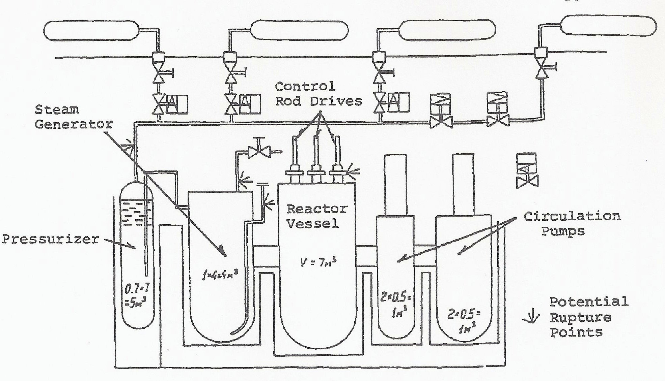

Fig.1. The primary circuit of the Komsomolets nuclear power plant with indication of where the high overpressure at the sea bottom is likely to have ruptured the circuit.

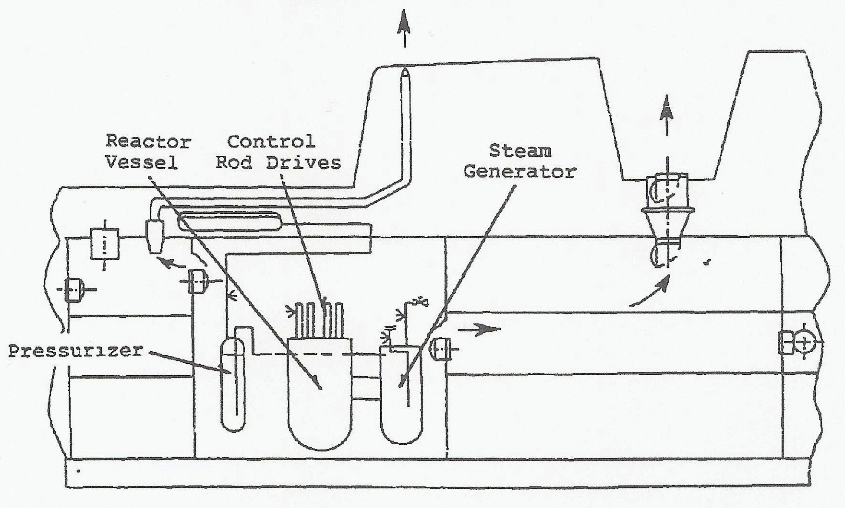
Fig.2. Probable leakage routes for radio-nuclides of the primary circuit of the Komsomolets submarine.

When the submarine started to sink, the rest of the crew transferred to life rafts. During this transfer the captain saved the life of another crew member just as he was to leave the sinking submarine. He then jumped into the water, but his strength had gone, and he died before reaching the life raft.
A western source says that 5 crew members, including the captain, sealed themselves in an escape capsule, installed in the conning tower. The capsule was already partly flooded and filled with smoke. It apparently failed to detach itself from the submarine immediately and did so only when the boat reached the sea-bed. When the capsule reached the surface and its hatch opened, 2 of the crew members were blown out in the ocean. One who had worn a breathing device survived, the other was lost. The 3 remaining crew members, including the captain, wore no breathing mask and died from asphyxiation.
The survivors had to stay in the rafts for several (3?) hours before the first Soviet rescue vessel arrived. Before they were picked up, or shortly afterwards, 36 died from the cold, wounds or drowning. Two additional crew members died later under rather strange circumstances. They felt fine after a medical examination at the naval hospital in Murmansk, but died suddenly after having smoked one cigarette each. If true, their death can hardly be due to radiation sickness as claimed by the media. Only 27 out of a total of 69 crew members survived the accident.
On April 8th a 400 m by 100 m oil slick was all that could be seen at the ocean surface at the scene of the accident. Shortly after the accident the submarine was located by deepwater submersibles of the Soviet Navy, and the pressure hull of the boat was inspected. No visible damage was detected around the reactor compartment. The fact that crew hatches, air vent pipes and some other systems were open when the submarine sank ensured pressure equalization between the inside and the outside of the boat. Photographs were taken of the submarine. In August 1991 water and bottom samples were taken in and around the submarine. The specific activity of the water measured in the reactor compartment did not exceed 3.10⁻⁶ Ci/l. All data collected indicate that the release of radioactivity so far has been very low as was to be expected.
According to Pravda the Komsomolets was a prototype of an ocean-going underwater ferry intended for high velocity transport of freight and passengers. According to western sources Komsomolets was an attack submarine, armed with SS-N-21 cruise missiles and (2?) heavy-weight type torpedoes. Both of these weapons could be nuclear armed.
Comments: The accident was caused by a fire which did not originate in the reactor compartment, and the reactor was shut down in an orderly way when the submarine reached the surface. When the reactor sank, the primary circuit had been cooled down to 40°C, and the remaining decay heat could undoubtedly be removed by natural circulation. After the submarine had reached the sea bottom, the pipes of the primary system ruptured due to the high outside pressure, but very little radioactivity has escaped. Conflicting evidence exists on the death of the captain, but this is not of importance for the course of the accident or its long term consequences. The description of the later death of two crew members sounds strange and may not be correct.

June 1989. Soviet Echo-II Class Submarine Accident
At 04.30 (Moscow time) on June 26, 1989, a leak developed in one of the components of the primary circuit of the nuclear power plant of an Echo-II class cruise missile submarine of the Northern Fleet on transit from the Mediterranean Sea to Severomorsk. At that time the submarine was located 350 km south of the Bear Island or 110 km north-west of Soroya in northern Norway. The nuclear propulsion system was shut down, the submarine surfaced, and the auxiliary diesel system started. By use of this system and towing the submarine sailed towards its home base in Severomorsk with a speed of about 5 knots. Smoke and/or steam rose from the submarine. The Soviet authorities stated that it was only smoke from the diesel plant while the Norwegian authorities were of the opinion that there was also steam, possibly coming from the leak in the reactor system.
The leak in the primary circuit was of such magnitude that the water supply in the submarine did not suffice to compensate for the leakage. For this reason ships were sent out to the submarine to supplement its fresh water supplies. The water leaking out of the primary system was not dumped overboard, but collected in a special tank.
Due to the shut-down of the reactors of the submarine the electric power production was substantially reduced. For this reason the air-condition system had to be switched off. This caused the temperature in the submarine to rise to 25 to 30 °C, and the crew was allowed on the deck to get fresh air.
The temperature of the reactor coolant continued to decrease. In the morning of June 26th, it was 150 °C, in the evening 120 °C. On June 27th it had dropped to 108 °C.
The submarine was visited by experts, including health physicists, on June 27th. They took water and air samples and found that the radiation situation was normal. According to Soviet statements there was no overexposure of the personnel and no risk of contamination. Sea water and air samples were taken both by soviet and Norwegian ships. The first Norwegian samples indicated no release of radioactivity from the submarine. Later there were indications of a small leakage since ¹³¹I and radio lanthanides were detected. One sample of water contained 0.02 Bq ¹³¹I /kg.
The submarine arrived at its home base on the Kola Peninsula on June 28th. The radiation level was found to be normal. Nevertheless 4 crew members were hospitalized for observation for radiation sickness. No sign of such sickness was found.
Later Norwegian measurements of air samples seem to indicate that ¹³¹I was also released to the atmosphere, probably contained in steam. The release could have taken place early during the accident to reduce the pressure in the reactor compartment. Norwegian authorities have interpreted the presence of ¹³¹I as indicating that a loss-of-coolant-accident and a partial core melt-down may have occurred.
Comments: The leak in the primary system must have been fairly large since new supplies of fresh water had to be delivered to the submarine. The very slow cooling-down of the primary system as compared e.g. to the Komsomolets accident (cfr. Apr. 1989) seems to indicate increased flow resistance through the core and thus reduced cooling. This increased friction could be due to fuel damage or possibly partial core melt-down.
The release of steam from the submarine, on which there is conflicting statements, could be done to avoid a too high pressure in the reactor compartment at the early phases of the accident. At this time the steam is not very radioactive since the fuel damage is still quite limited. A somewhat similar system exists in the early USSR-designed VVER-230 power plants. It should also be noticed that the distillation process has a quite high decontamination factor so that only a small part of the radioactive nuclides released from the damaged fuel will be carried away with the steam. This could be the reason why only very low concentrations of 1311 were measured.

July 1989. Soviet Alfa Class Submarine Incident
On July 17, 1989, the Norwegian authorities announced that fire had broken out in an Alfa-class submarine in the Barents Sea, 120 km east of Vardo in northern Norway. Initially the soviet authorities announced that the smoke was part of a military exercise. However, later it was stated that while the submarine was submerged during a naval exercise the control system indicated a fault in the reactor system. The reactor was shut down and the submarine surfaced. Here the diesel engine was started, and it was the smoke from this engine that looked as a fire. The alarm of the control system is believed to be an error. The submarine returned to its base on the Kola Peninsula. Water samples, taken by the Norwegian authorities in the area, contained small amounts of ¹³¹I, presumably originating from the submarine.
Comments: The second Soviet statement sounds reasonable though it is always a bit worrying when an explanation is changed. Since no figures are available on the ¹³¹I content of the sea water samples it is difficult to assess whether it is a sign of an accident or not. Since the submarine sailed back to base without any assistance it seems reasonable to classify the event as an incident.

Jan. 1990. Soviet Admiral Ushakov Class Cruiser Incident
According to reports of unknown origin the Soviet nuclear powered cruiser Admiral Ushakov (ex Kirov) had problems with one of its two reactors in January 1990 when the ship was cruising in the Mediterranean. The incident seems to have involved a small leakage in the primary circuit. The cruiser returned to its base on the Kola Peninsula on its own power.
Comments: If the event actually occurred, it seems reasonable to characterize it as an incident since the cruiser could return to base without external assistance.

5. POTENTIAL RISKS OF NUCLEAR NAVAL ACCIDENTS
To understand the course of nuclear naval accidents it is first of all necessary to determine what types of reactors were used in the ships.
The dominating reactor type for naval propulsion is the pressurized water reactor (PWR). This is true for U.S., Russia, U.K., France and China. The PWR has the advantage that it can, for a given power level, be designed with a small core because of the excellent slowing-down properties of water. A small core and a small reactor tank - is of course of greatest importance for ships where space requirements are of major importance.
The second U.S. nuclear submarine was initially provided with a liquid-metal (sodium) cooled, intermediate reactor (SIR) with beryllium as a moderator. This type of reactor can also be made quite compact, and it has the additional advantage that the so-called xenon poisoning, which may impede the startup of a PWR up to 24 hours after shut-down, is of no importance to a SIR. However, leaks in the steam generator where hot water comes in contact with liquid sodium, caused the U.S. Navy to remove the SIR and replace it with a PWR power plant. Since then all U.S. nuclear naval ships have been provided with PWR's.
In the USSR the PWR has also been the dominating naval reactor. However, it has been claimed in some western publications that the Alfa class submarines were provided with a liquid metal cooled reactor using a lead-bismuth coolant. In addition it has been claimed that the Komsomolets was probably also provided with a liquid metal cooled reactor. The latter claim has later proved wrong. When the Komsomolets sank, an official Soviet statement said that the submarine was provided with a single pressurized water reactor. It might well be that the claim for the Alfa class reactor is equally wrong.
In the following it will be assumed that all naval reactors are PWR's.
It is beyond the scope of this paper to give a thorough discussion of the safety aspects of PWR's, but a few comments should be made.
There exists two main classes of PWR accidents. One is a sudden, uncontrolled increase in power level of the reactor. If this increase lasts for sufficiently long time the reactor fuel will be damaged and radioactivity released to the primary reactor circuit. Such an accident may ultimately result in a reactor melt-down. It may arise if for some, most improbable reason the drive mechanism of the control rods is damaged and that this damage results in the withdrawal of the control rods from the reactor at maximum speed. Another improbable possibility is a sudden injection of large amounts of cold water into the reactor. In both cases the control rods will be released and drop down into the reactor as soon as a preset power level is reached or as soon as the rate of increase of the power exceeds a preset value. In addition the sudden increase in the power level will raise the reactor pressure, the safety valves will be activated and the boiling will start in the reactor whereby the reactor becomes subcritical and the power level decreases. Experience has shown that this type of accident is very unlikely and has to the knowledge of the author of this report never occurred in naval reactors.
The other type of accident is connected to the high pressure (100 to 200 atm.) of the primary circuit of the nuclear power plant (reactor, steam generator(s) and pump(s), see fig. 3) and the corrosive nature of hot water. If a large leak in this circuit occurs, e.g. due to corrosion or a defect gasket, a steam-water mixture will flow out through the leak with great velocity and the pressure of the primary circuit will decrease. The control rods will automatically drop into the reactor and stop the chain reaction. But the reactor will continue to produce power, though at a reduced level, due to the radioactive decay of the fission products in the reactor fuel.

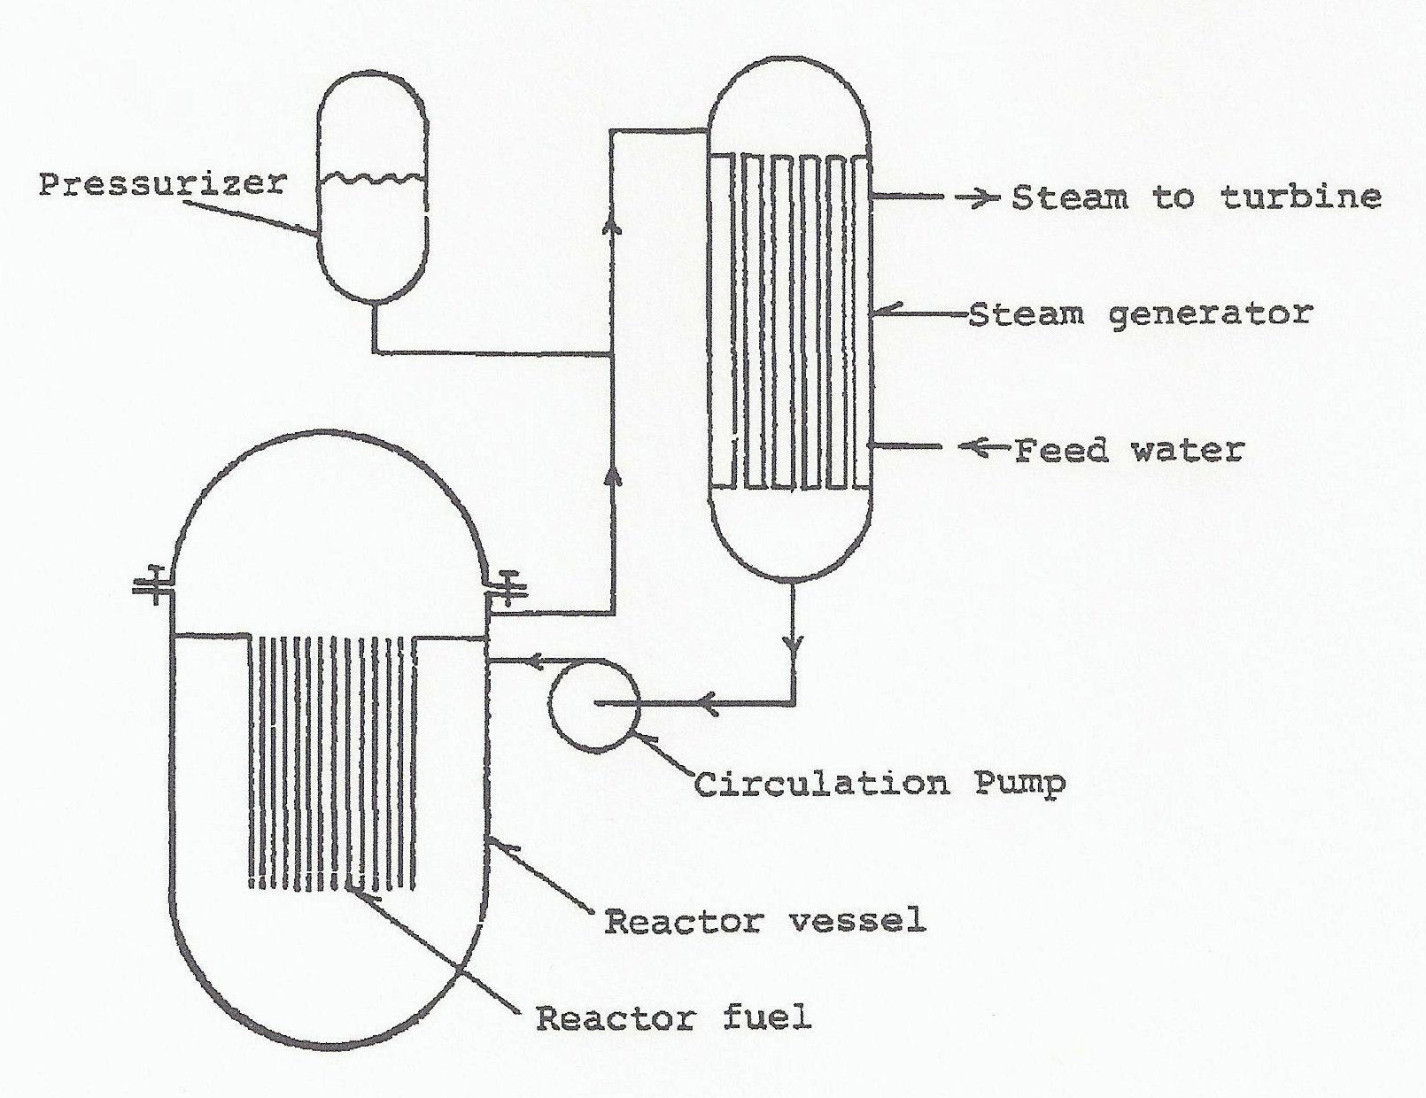
Fig.3. Primary circuit of a pressurized water reactor (PWR).

If the leaking water is not rapidly replaced by an emergency core cooling system, the water level in the reactor vessel will drop below the top of the reactor fuel, and the upper part of the reactor fuel will not be sufficiently cooled. The fuel temperature will increase, and if the reactor cooling is not rapidly reestablished, the fuel will overheat, the protective cladding will be damaged and radioactive fuel particles leak out in the primary circuit. Ultimately the fuel may start to melt.
The seriousness of such an accident depends of course of the size of the leak. If it is sufficiently small, the loss of cooling water can easily be replaced, and the reactor shut down and repaired in a safe way. Such an event is an incident. However due to the high pressure of the primary circuit and the corrosive nature of hot water, there is always the risk - even though the probability is low - of the development of a major leak. Such a leak may lead to damage of the fuel and release of radioactive material to the surroundings. As is obvious from the events discussed in section 4 this is not an academic possibility.

6. ANALYSIS OF THE ACCIDENTS/INCIDENTS
The number of events considered here are so few and the information about them so dubious that one has to be careful in using thee for statistics. This has nevertheless been attempted.
The event list given in section 4 contains 5 events involving U.S. submarines. Of these 4 events seem to involve leakage of sea water into the submarine, and in 2 of these cases the submarines were lost. Thus the early U.S. nuclear submarines seem to have had a weak design with respect to sea water leaks. The fifth event is the only that involves the nuclear power plant; it was a small leak in the primary circuit that could be repaired at sea without external assistance. Thus the U. S. naval reactors appear to be of high quality.
Section 4 contains 23 events involving Soviet ships. Of these it seems reasonable to neglect 3, the 1966 Lenin-event and the 1968 event due to doubtful, available evidence, and the Apr.-May 1970 event since this accident is believed to be identical to the Apr. 1970 event. This leaves 20 events.
Of these 7 were caused by fires/explosions, and in 3 cases the submarine was lost. This seems to indicate that Soviet submarines were not designed properly with respect to fire prevention or that the crews were not sufficiently trained in this area or both. Similar criticism has been raised with respect to USSR civilian nuclear power stations.
In 5 events a leak in the primary circuit of the nuclear power plant developed. In an additional 5 events there was a loss of propulsion which may also have involved the reactor system, possibly through leaks in the primary circuit. Finally there is one radiation accident which, if real, should have involved the reactor. Problems with leaks were also experienced with the first nuclear power plant on NS Lenin. It seems that in particular the first generation nuclear power plants in the Hotel-, Echo-, and
November-class submarines had a weak design with respect to risk of leaks in the primary system. In the west it has been guessed that the first reactors of NS Lenin were identical with those of the first generation of Soviet submarine. As mentioned above the first reactors of NS Lenin had also leak problems.
The emergency core cooling system of these reactors seems to have had too low capacity. In some accidents the leaks may have been so large and the capacity of the emergency core cooling system so limited that serious fuel damage has occurred. It has been reported that the Soviets have dumped reactor's vessels containing the reactor fuel in the in the Barents and Kara Sea. These reactors may originate from such accidents.
As far as is known the U.S. naval reactors are provided with a containment to prevent any leak of radioactive material from spreading outside the reactor room. From the information available it seems as if at least the early USSR naval reactors were not provided with containment except for the fact that submarines are divided in compartments separated by bulkheads.
Criticism both with respect to insufficient emergency core cooling system and lack of containment has been raised against the civilian nuclear power stations of the USSR.
Only in one event seems a leak of sea water into the submarine to have been the reason for the accident.
7. CONCLUDING REMARKS
In this report available information on accidents with nuclear ships has been reviewed, and an attempt to evaluate the information has been made. As already mentioned the information presented may not be correct and consequently the analyses may not be correct either. The author of this report would appreciate very much to receive any additional information, corrections or criticism of the information and analyses so that any later, revised version of this report can be more correct.

8. REFERENCES
1. P.L.Olgaard: Civilian nuclear ships. NT-1 (Rev). Dep. of Electrophysics, Tech. Univ. of Denmark. Mar. 1993.
2. V.O.Eriksen: Sunken nuclear submarine. Norwegian University Press, Oslo, 1990.
3. J.M.Dukert: Nuclear ships of the world. Coward, McCann & Geoghegan Inc., New York, 1973.
4. W.M.Arkin and J. Handler: Naval accidents 1945-1988. Neptune Papers No.3, Greenpeace/Institute for Policy studies, June 1989.

